In the
United States Court of Appeals
For the Seventh Circuit

No. 14‐3678 DISCOUNT INN, INC.,

v.

Plaintiff‐Appellant,

CITY OF CHICAGO,

Defendant‐Appellee.

Appeal from the United States District Court for the Northern District of Illinois, Eastern Division.
No. 13 C 7168 — Charles R. Norgle, Judge.

ARGUED SEPTEMBER 16, 2015— DECIDED SEPTEMBER 28, 2015

Before POSNER, EASTERBROOK, and WILLIAMS, Circuit Judges.
POSNER, Circuit Judge. In 2013 and 2014, Chicago’s De‐ partment of Administrative Hearings determined that the plaintiff in this case, Discount Inn, Inc., had violated two City ordinances—the weed ordinance and the fencing ordi‐ nance. The weed ordinance provides that “any person who owns or controls property within the city must cut or other‐ wise control all weeds on such property so that the average

height of such weeds does not exceed ten inches. Any person who violates this subsection shall be subject to a fine of not less than $600 nor more than $1,200. Each day that such vio‐ lation continues shall be considered a separate offense to which a separate fine shall apply.” Municipal Code of Chi‐ cago § 7‐28‐120(a). (Notice that “weed” is not defined; this omission will become important later in our opinion.)
The fencing ordinance provides that “it shall be the duty of the owner of any open lot located within the City of Chi‐ cago to cause the lot to be surrounded with a noncombus‐ tible screen fence … . Provided, however, that this section shall not apply to … sideyards. The owner shall maintain any such fence in a safe condition without tears, breaks, rust, splinters or dangerous protuberances and in a manner that does not endanger or threaten to endanger vehicular traffic by obstructing the view of drivers. Any fence which is not maintained in accordance with these provisions is hereby declared to be a public nuisance and shall be removed … . It shall be the duty of the owner of any lot whose fence has been so removed to replace such fence with a noncombus‐ tible screen fence meeting the requirements of this section and of this Code.” Municipal Code of Chicago § 7‐28‐750(a). Violators “shall be fined not less than $300 nor more than
$600 for each offense,” and “each day such violation contin‐ ues shall constitute a separate and distinct offense to which a separate fine shall apply.” § 7‐28‐750(d).
The plaintiff seeks to invalidate both ordinances as viola‐ tions of the Constitution; it also seeks recovery of the fines that it has paid for violating them—it claims to have been fined more than twenty times, and to have paid all the fines without seeking judicial review. The district judge dismissed

the complaint for failure to state a claim, precipitating this appeal.
An oddity of this case is that nowhere in the briefs, or in the district court’s opinion, or elsewhere in the record is there any information about Discount Inn except that it is incorporated in Illinois and its address is in Skokie—a city separate from Chicago. Virtually all that we’ve been able to learn about the company is that it owns real estate in Chica‐ go. Discount Inn does not have a website, or a Dun & Brad‐ street report, or more than a tiny handful of Internet refer‐ ences, none of which describes its business. The address in Skokie is a private home in a suburban subdivision. The home is owned by a person named Baba Abdul Jubbar, who also has no website, and the property apparently is the headquarters not only of Discount Inn but also of the Solo Land Corp. and SNS General Corp., which also do not have websites. And it seems that a “Suzie Baba” is president of at least four other corporations at that address. See Entity Source, “Sns General Corp.,” www.entitysource.com/details/ entity/il_56915826/sns‐general‐corp. (visited September 28, 2015, as were the other websites cited in this opinion). An article in the East St. Louis Monitor of September 20, 2012, “Nightclubs and Convenience Marts Charged,” www. estlmonitor.com, reports that Discount Inn owned “derelict properties” in that city. We can discover nothing about Dis‐ count Inn’s properties in Chicago or the specifics of its viola‐ tions of the weed and fence ordinances.
Although the factual vacuum does not prevent our decid‐ ing the case, we take this opportunity to advise counsel for future litigants to provide judges with some minimal back‐

ground information about their clients—some sense of con‐ text—to help the judges make sense of their case.
Discount Inn’s complaint makes two principal claims. The first is that the challenged ordinances violate the prohi‐ bition in the Eighth Amendment of “excessive fines.” The Supreme Court has not decided whether this clause of the amendment is applicable to state action by virtue of the due process clause of the Fourteenth Amendment—the vehicle by which a number of provisions of the Bill of Rights have been held to apply to the states and their local governments. McDonald v. City of Chicago, 561 U.S. 742, 765 n. 13 (2010). We assumed in Towers v. City of Chicago, 173 F.3d 619 (7th Cir. 1999), that it does apply, but the only basis of our assump‐ tion was that the parties had “not disputed that the Eighth Amendment’s Excessive Fines Clause applies to the civil penalties at issue in this case.” Id. at 623–24. (As in this case, the penalties in Towers had been imposed by the City of Chi‐ cago rather than by the federal government.) We can indulge the same assumption in this case because the fines imposed by the challenged ordinances are not excessive even if the “excessive fines” clause is applicable. At the oral argument Discount Inn’s lawyer stated that any fine above $200 would be unconstitutional, but he made no effort to explain how
$200 would be sufficient to achieve the objectives of the weed and fencing ordinances. Depending on the probability that a violation of such an ordinance would be detected, the expected (as distinct from the nominal) expense of a viola‐ tion might be too slight to have a deterrent effect. (If the probability of being fined $200 is only 10 percent, the ex‐ pected cost is only $20.)

We’ll consider shortly whether the weed ordinance ful‐ fills a legitimate governmental interest (if it does not, a fine for violating it would indeed be excessive); plainly the fenc‐ ing ordinance does, so there has to be a nontrivial penalty for violating it in order to induce even minimal compliance. A fine topped off at $600 can hardly be deemed an excessive penalty for violating the ordinance. The fencing of vacant lots is important to enable the identification of such land as being owned rather than abandoned, and relatedly to dis‐ courage squatters and also to discourage the use of vacant lots as sites for the sale and purchase of illegal drugs, as in Morrow v. May, 735 F.3d 639, 640–41 (7th Cir. 2013), and to protect people from injuring themselves in vacant lots pitted with holes or from encountering poison ivy, feral cats, wild dogs, or even coyotes, which have become common in Chi‐ cago. See Dawn Rhodes, “Coyotes Finding New Home in Downtown Chicago,” Chicago Tribune, January 16, 2015, www.chicagotribune.com/news/ct‐downtown‐coyotes‐met‐ 0117‐20150116‐story.html. These public benefits of requiring that vacant lots be fenced are sufficient to justify the modest fines that the City imposes on property owners who fail to fence their vacant lots.
The weed ordinance presents more difficult questions, though not because the maximum fine is twice as great as for violations of the fencing ordinance. (We haven’t been told, and have no idea, why the difference.) There is the difficulty of calculating the average height (which remember is not to exceed ten inches) of the weeds in what may be a large lot. We assume that the City employees who enforce the ordi‐ nance do not attempt precise measurement, but instead make a rough estimate of the average height of the weeds; there seems no practicable alternative—imagine trying to

measure the height of each weed in a lot and then averaging the heights of all the weeds.
The second question the ordinance presents is the social purpose of a weed ordinance; for if there is none, or very lit‐ tle, the maximum fine, although not large as fines go, may be excessive. Towers v. City of Chicago, supra, 173 F.3d at 624–26. The City explains, however, that “high weeds can conceal illegal activities, obscure dangerous debris, harbor rodents, serve as a breeding ground for mosquitoes and West Nile Virus and contribute to allergies and breathing difficulties. That’s why Streets & Sanitation’s Bureau of Street Opera‐ tions is aggressive about keeping overgrown weeds from becoming a problem in our neighborhoods.” City of Chica‐ go, City Service, “Weed Cutting/Weed Removal,” www.cityofchicago.org/city/en/depts/streets/provdrs/street/ svcs/weed_control.html. Weeds also tend to spread and in spreading kill plants that are valued for beauty, fragrance, nutritional value, etc.
But there is an ambiguity in the concept of a “weed,” an ambiguity brought out by comparing “weed” to ”native plant.” A native plant, like a weed (or perhaps it could be thought of as an elite type of weed), is “born” and matures normally without human intervention although it may also have been deliberately planted. It need not be destructive. In contrast, an “invasive plant species” enters either naturally or by human transport into an area in which native or other valued plants are growing, and squeezes out or otherwise injures or destroys those plants. Cf. 40 C.F.R. § 166.3, defin‐ ing “invasive species” for purposes of federal pesticide regu‐ lations as “any species that is not native to [a particular] eco‐

system, and whose introduction does or is likely to cause economic or environmental harm or harm to human health.”
Unmanaged invasive plant species are largely synony‐ mous with “weeds.” Weeds interfere with other plants and other horticultural and environmental goals by ”competing with the desired plants for the resources that a plant typical‐ ly needs, namely, direct sunlight, soil nutrients, water, and (to a lesser extent) space for growth; providing hosts and vectors for plant pathogens, giving them greater opportunity to infect and degrade the quality of the desired plants; providing food or shelter for animal pests such as seed‐ eating birds and Tephritid fruit flies that otherwise could hardly survive seasonal shortages; offering irritation to the skin or digestive tracts of people or animals, either physical irritation via thorns, prickles, or burs, or chemical irritation via natural poisons or irritants in the weed … ; causing root damage to engineering works such as drains, road surfaces, and foundations, blocking streams and rivulets.” Wikipedia, “Weed,” https://en.wikipedia.org/wiki/Weed. Chicago has a valid ecological interest in weed control, an interest that jus‐ tifies an ordinance forbidding tall weeds. A far from astro‐ nomical fine such as $1200, aimed at limiting the City’s weed population, is not “excessive” in the sense that the word bears in the Eighth Amendment.
Discount Inn also contends that the weed ordinance is vague and forbids expressive activity protected by the First Amendment. The concern is that native plants, while sharing with weeds the property of not having to be planted, are, un‐ like weeds, beautiful and nondestructive when properly managed. Here’s an example, picked at random; it is a pic‐

ture of the plant, native to the west coast, called “salmonber‐ ry”:

And here are a photo of a community garden in which the gardeners cultivate Illinois native plants, in the Wicker Park neighborhood of Chicago; a photo of a private garden in the Hyde Park neighborhood, exhibiting native Asters; and a photo of a vacant lot submerged by weeds that nearly cover the cars in the background.

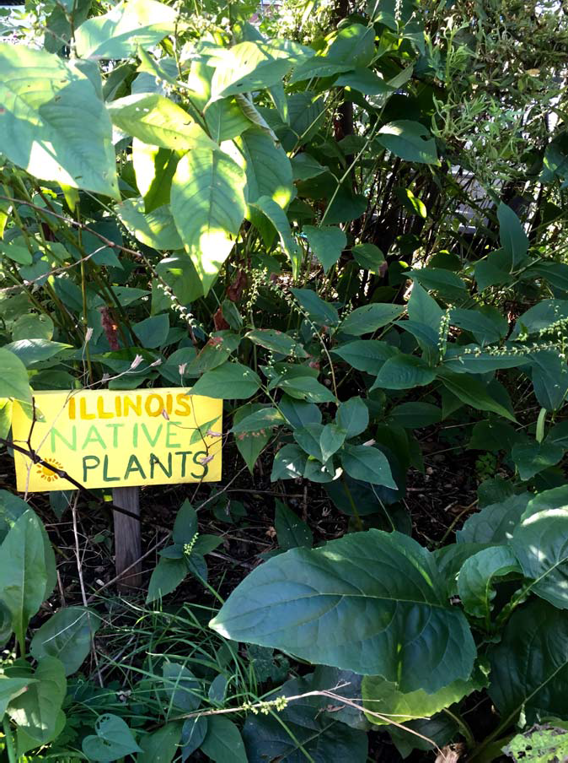

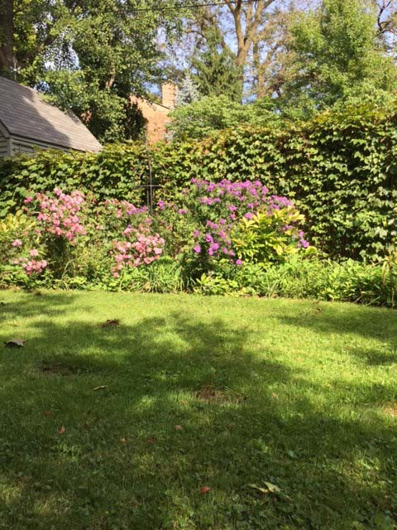

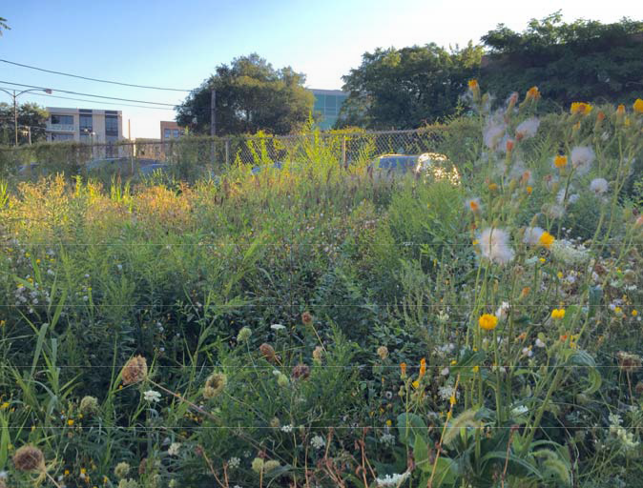

A legitimate concern of property owners who grow na‐ tive plants is that enforcers of the weed ordinance will mis‐ take native plants for “weeds,” an undefined term in the or‐ dinance, as we said. However, a provision of the City’s “Rules and Regulations for Weed Control,” designed “to ac‐ complish the purposes of Section 7‐28‐120 of the Municipal Code of Chicago” (the weed ordinance), defines “weed” as “vegetation that is not managed or maintained by the person who owns or controls the property on which all such vegeta‐ tion is located and which, on average, exceeds ten inches in height.” Interpreted literally this would embrace all vegeta‐ tion on the property. (And what about trees? They’re vegeta‐ tion. A lot full of ten‐inch tall trees would be a sight.) A bet‐ ter definition of “weed” would be “a wild plant growing where it isn’t wanted.” That would dispense with the irrele‐

vant issue of origin. The dandelion is “native” to the Mid‐ west by any measure; so is crabgrass; but dandelions and crabgrass on a lawn are weeds.
It is possible that the City recognizes the distinction be‐ tween weeds and other native plants; for the preamble to the regulation just cited that defines “weed” states that “while promoting the use of native vegetation, the City of Chicago wants to continue to require property owners and persons in control of property to manage and maintain vegetation growing on their property.” This could mean that the aver‐ age height of any vegetation must indeed not exceed ten inches; or it could make an exception for native plants that are bought and planted, as has become common; or it could except all native plants. The latter two interpretations would be consistent with the ordinance—except that the City’s en‐ forcers may not be able to distinguish between weeds and native plants without instruction that, so far as we know, they are not given. Furthermore, as in the dandelion exam‐ ple, some weeds are “native” to the Midwest, whereas “na‐ tive plants” as the term is usually used has a positive conno‐ tation.
Notice also that while it is sensible to require the proper‐ ty owner to “manage” vegetation growing on his property, it’s not clear why he should be required to “maintain” it. The vegetation may consist entirely of weeds, which the City does not want property owners to “maintain.” The City says in its brief that “manage and maintain” include “protect[ing] those plants from harm from pests and the elements”––and “those plants” appear to include weeds. Adding to the con‐ fusion, the regulation we cited from the City’s “Rules and Regulations for Weed Control” states that “the City of Chi‐

cago promotes the use of native vegetation as a means to conserve water and to reduce carbon dioxide emissions”— yet in the next sentence repeats the requirement that proper‐ ty owners are “to manage and maintain the vegetation grow‐ ing on their property,” a statement that seems to lump na‐ tive plants in with weeds.
Even if we assume (as is plausible) that the weed ordi‐ nance does not embrace native‐plant gardens, this can do nothing for Discount Inn, because it does not argue that its properties contain gardens of native or other decorative plants. Instead it argues that the ten‐inch ceiling on weeds violates the free‐speech clause of the First Amendment.
Though plants do not speak, this need not exclude all gardens from the protection of the clause, for the clause has been expanded by judicial interpretation to embrace other silent expression, such as paintings. See, e.g., Hurley v. Irish‐ American Gay, Lesbian & Bisexual Group of Boston, 515 U.S. 557, 569 (1995) (“a narrow, succinctly articulable message is not a condition of constitutional protection, which if con‐ fined to expressions conveying a particularized message, would never reach the unquestionably shielded painting of Jackson Pollock, music of Arnold Schöenberg, or Jabber‐ wocky verse of Lewis Carroll” (citation omitted)). The gar‐ dens of Sissinghurst Castle and of Giverny might well be recognized as works of art were they in the United States. There may be gardens in Chicago, whether consisting of na‐ tive or other plants, that are or should be recognized as works of art. See Chris Coffey, “Gardeners Challenge Chica‐ go Weed Control Rules—Gardeners Complain of Vague Weed Control Ordinance,” NBC 5 Investigates, www.nbc chicago.com/investigations/Gardeners‐Challenge‐Chicago‐

Weed‐Control‐Rules‐269489511.html. The City’s brief acknowledges that “some gardens and landscaping projects might arguably constitute expressive conduct,” though the concession is grudging, if it’s a concession at all—“might ar‐ guably” suggests it isn’t.
But the plaintiff’s claim that the free‐speech clause insu‐ lates all weeds from public control is ridiculous. It’s not as if the plaintiff invented, planted, nurtured, dyed, clipped, or has otherwise beautified its weeds, or that it exhibits or in‐ tends or aspires to exhibit them in museums or flower shows. Its weeds have no expressive dimension. The plain‐ tiff just doesn’t want to be bothered with having to have them clipped.
We must be careful not to impose a minimal standard of “expressiveness” for determining when an object is art and therefore protected by the First Amendment from govern‐ ment prohibition or destruction. In 1917 Marcel Duchamp exhibited a urinal that he called “Fountain”—it is a famous work of art, though Duchamp had not designed, built, al‐ tered, or decorated the urinal. But Discount Inn does not claim to have added anything to the weeds that grow on its lots—not even a name. Allowing weeds to grow tall cannot, in and of itself, be regarded as creating works of art.
Taken to its logical extreme, the plaintiff’s defense of the weed would preclude any efforts by local governments to prevent unsightly or dangerous uses of private property. Homeowners would be free to strew garbage on their front lawn, graze sheep there, and broadcast Beethoven’s Fifth Symphony 24 hours a day through outdoor loudspeakers— all in the name of the First Amendment.

We do worry that compliance with the weed ordinance may be difficult. We are not reassured by the City’s state‐ ment that a property owner “can use a ruler to determine whether a plant is more or less than ten inches tall and can likewise use simple arithmetic to determine the average height of the plants on his property.” What if there are a thousand plants, and therefore a thousand measurements to be made and the results then averaged? But difficulty of compliance is not a persuasive ground for deeming the ordi‐ nance unconstitutional.
It remains only to mention the plaintiff’s further argu‐ ment that the ordinances are unconstitutional because they fail to specify a statute of limitations. There is no rule, in the Constitution or for that matter common law, that every claim must have a cut‐off date; first‐degree murder statutes, for example, do not prescribe limitations periods. It would be very difficult to design a statute of limitations for en‐ forcement of the weed or fencing ordinance. When would the limitations period begin to run? When the vegetation on a property first reached ten inches? (But when would that be discovered?) When a fence enclosing a vacant lot collapsed, or the lot was sold? The City can hardly monitor every lawn and yard in Chicago so that it will learn the exact day on which someone’s average vegetation reaches the forbidden level, or his fence collapses. It’s amusing to think of hun‐ dreds of civil servants fanning out across Chicago, each clutching a ruler plus a calculator (to determine the average of all the measurements that the investigator takes of the vegetation on a given lot) and being careful not only to rec‐ ord the date but also to learn if possible the date on which the average vegetation had exceeded the permitted height, and, if there is no fence around a vacant lot, how long that

situation has persisted. Such a deployment of the City’s em‐ ployees would be a preposterous use of public resources, however, and the plaintiffs don’t claim that upon discover‐ ing a violation the City tries to determine when it began, in order to be able to multiply the fine by as many days as the violation has continued.
AFFIRMED

